**Name - Divyani Khade**

**Batch - 6th Feb Python Fullstack with Data Science**

**Date - 23rd April, 2025**

1. **Output -**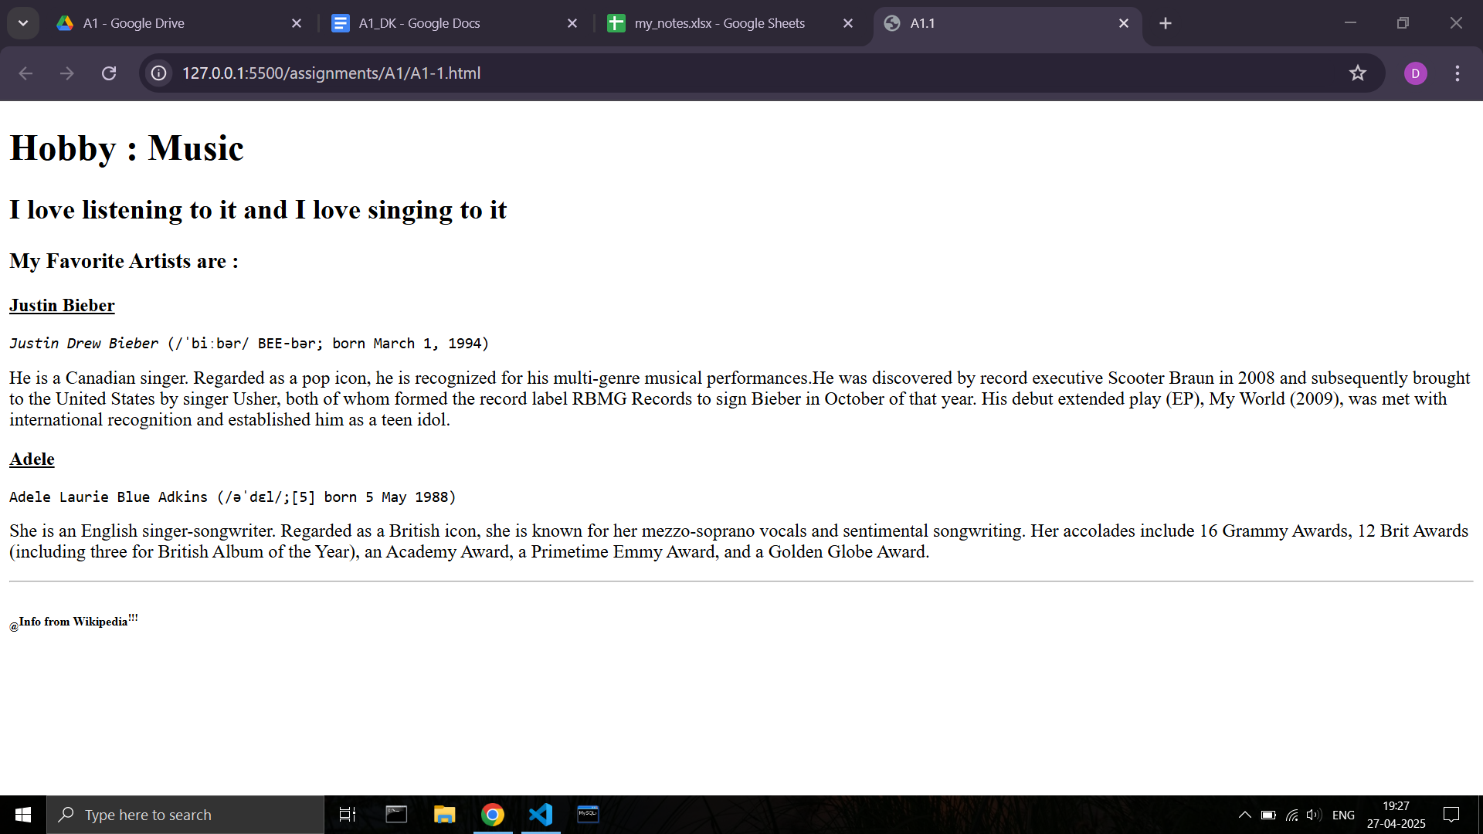

**Code -**

**<!DOCTYPE html>**

**<html lang="en">**

**<head>**

**<meta charset="UTF-8">**

**<meta name="viewport" content="width=device-width, initial-scale=1.0">**

**<title>A1.1</title>**

**</head>**

**<body>**

**<h1>Hobby : Music</h1>**

**<h2>I love listening to it and I love singing to it</h2>**

**<h3>My Favorite Artists are :</h3>**

**<b><u>Justin Bieber</u></b><br>**

**<p>**

**<pre><i>Justin Drew Bieber </i>(/ˈbiːbər/ BEE-bər; born March 1, 1994)</pre>**

**He is a Canadian singer. Regarded as a pop icon, he is recognized for his multi-genre musical performances.He was discovered by record executive Scooter Braun in 2008 and subsequently brought to the United States by singer Usher, both of whom formed the record label RBMG Records to sign Bieber in October of that year. His debut extended play (EP), My World (2009), was met with international recognition and established him as a teen idol.**

**</p>**

**<b><u>Adele</u></b>**

**<p>**

**<pre>Adele Laurie Blue Adkins (/əˈdɛl/;[5] born 5 May 1988)</pre>**

**She is an English singer-songwriter. Regarded as a British icon, she is known for her mezzo-soprano vocals and sentimental songwriting. Her accolades include 16 Grammy Awards, 12 Brit Awards (including three for British Album of the Year), an Academy Award, a Primetime Emmy Award, and a Golden Globe Award.**

**</p>**

**<hr>**

**<h6><sub>@</sub>Info from Wikipedia<sup>!!!</sup></h6>**

**</body>**

**</html>**

1. **Output -**

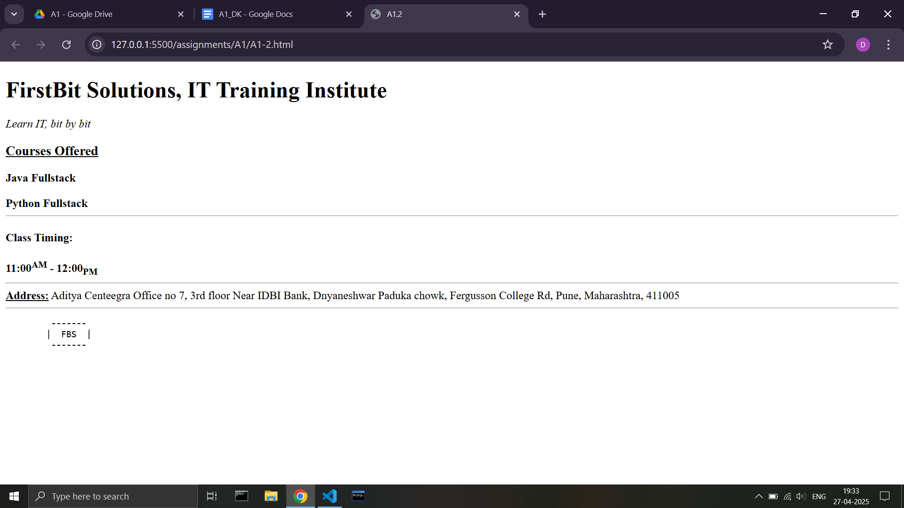

**Code -**

**<html>**

**<head>**

**<title>A1.2</title>**

**</head>**

**<body>**

**<h1>FirstBit Solutions, IT Training Institute</h1>**

**<i>Learn IT, bit by bit</i>**

**<h3><u>Courses Offered</u></h3>**

**<b>Java Fullstack</b>**

**<br><br>**

**<b>Python Fullstack</b>**

**<hr>**

**<h4>Class Timing:</h4>**

**<b>11:00<sup>AM</sup> - 12:00<sub>PM</sub></b>**

**<hr>**

**<b><u>Address:</u></b>**

**Aditya Centeegra Office no 7, 3rd floor Near IDBI Bank, Dnyaneshwar Paduka chowk, Fergusson College Rd, Pune, Maharashtra, 411005**

**<hr>**

**<pre>**

**-------**

**| FBS |**

**-------**

**</pre>**

**</body>**

**</html>**